Position Title: | Graduate Management Trainee | Date Finalised/Last Reviewed: |  |  | 14.12.18
Business Unit /Function: | TW Head Office- Human Resources
Reports to: | Human Resources/ Functional Head
Subordinate Positions: | N/A
Job summary/purpose:
Taylor Wimpey is now recruiting for our 2018 Graduate Programme beginning in September 2018. The scheme aims to provide a carefully selected group of graduates with a strong commercial grounding and an introduction to house building. You will have the opportunity to work across several different business functions and office locations across the UK to gain a full appreciation of the build life cycle, support functions and how Taylor Wimpey delivers one of the most successful business models in the industry.

The aim of the scheme is to place graduates into permanent positions at the end of a 2 year programme.
Graduate Scheme Outline
- Our programme is a 2 year rotational scheme, where you will spend time in all areas of the business including; production, commercial, technical, sales and marketing, customer service, land and finance.
- Rotations will be a minimum of 6 months long and graduates will have the opportunity to spend time in a variety of our 24 regional offices located all across the UK.
- If successful, you will be placed in a designated geographical division with a number of business units within each division. Three out of the four rotations will be within the geographical division and the second placement will be outside of your division.
- Successful candidates will all attend a 5 day residential induction programme where you will be given the opportunity to learn about the business in more detail, find out more about the 2 year programme and what it will bring and also get the chance to meet other Graduates in your cohort.
- At the end of each business rotation, you will be given a full review of your performance which will contribute to an overall portfolio of your development.
- Senior leaders within the business will monitor your progress and you will be supported in achieving professional and/or other appropriate qualifications if required.
- Successful graduates will attend a number of Taylor Wimpey ‘Skills Camps’ that provide ongoing development support over two years. They are designed to improve, amongst other things, your commercial awareness, management ability and personal skills. These will also provide an opportunity to hear from Senior Directors and their experiences of working for Taylor Wimpey.
- You will also work on different projects during the 2 years, alongside your fellow graduates. These will include a charity project and an internal business project.
- At the end of the 2 year programme, all successful candidates will be offered a role within the organisation.

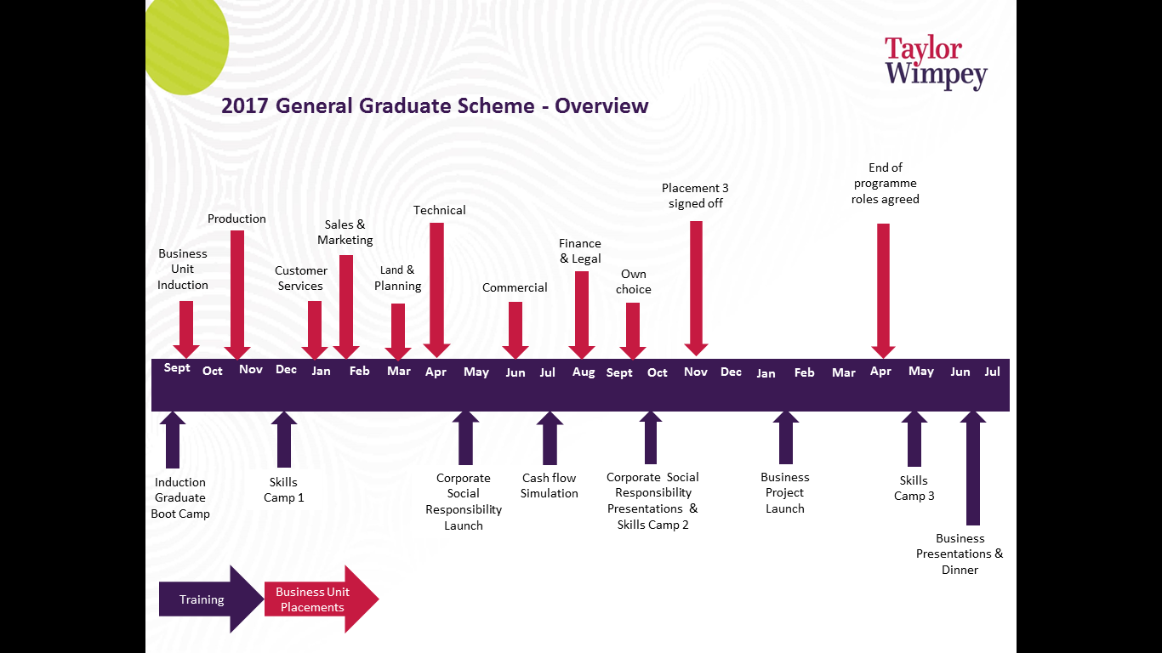
Graduate Scheme Rotations
- Site Production areas include: Health & Safety, Build Stages and Key Stage Inspections. Team working with sales: Customer Visits. Principles of the Site Inspection visits and National House Building Control.
- Customer Care areas include: Dealing with customer complaints and resolving problems, site visits with Customer Relationship Manager and Maintenance Repair Technicians. Work towards new Home Quality Inspection standard.
- Sales & Marketing areas include: Understanding the Sales Process and Selling Skills. Managing Customer Expectations. Market and Competitor Research. Consumer Code and Property Misdescription Act training.
- Land & Planning areas include: Appraisal and Acquisition of land, preparation of information for Land Purchase Exercise. Understanding of planning process including obtaining planning permission, agreements and consents. Attend public exhibitions. Understand factors which affect development cost.
- Technical (Engineering & Architects) areas include: Design issues which affect cost and level of information required to build effectively and control cost. Manage external consultants. Overview of Utilities provisions. Knowledge of standard product specification.
- Commercial areas include: Work on subcontract and material buying functions and national agreements. Measurement and preparation of labour targets. Analysing subcontractor quotes. Estimating and site valuations.
- Finance & Legal areas include: Budgets and financial reporting to Head Office. Legal aspects of home buying from customer and business perspective.

What are the measures of success for this position?
Graduates will be measured against the graduate key behaviours in 6 monthly reviews for each Business Unit rotation.

Experience, Qualifications, Technical Requirements, Education Required/Preferred
Please describe at least 5 qualifications, technical requirements or qualifications necessary for the role |  |  |  | Please Select Preferred or Required
1st or 2:1 degree |  |  |  | Required
Full driving license and access to a car |  |  |  | Required
Eligible to work in the UK |  |  |  | Required
Willingness to travel around the UK and are happy to stay away from home for extended periods of time. |  |  |  | Required
Commercial experience or placement within a bluechip organization. |  |  |  | Preferred
Key Behaviours
Resilience |  |  | The ability to recover quickly from challenging situations and provide effective solutions to problems
Collaboration |  |  | Comfortable working in a team on various projects and takes constructive criticism. Able to influence others where appropriate
Accountability |  |  | Take full responsibility for own actions and can offer justification for them when required
Risk taking |  |  | Comfortable taking calculated risks when appropriate and can learn from previous mistakes
Challenging |  |  | Willing to challenge the norm, that are not afraid to speak their mind when they believe it is appropriate and that will make their voice heard when they firmly believe they are in the right
Ambitious |  |  | Strong desire to succeed, both professionally and personally and have a clear plan on how to achieve objectives
Solution-focused |  |  | Draws effective and valid conclusions based on analysis
Resilience& Perseverance |  |  | Can identify alternative approaches to achieve the objective and will push others to achieve.
Pace & Energy |  |  | Shows passion and enthusiasm to meet objectives quickly and effectively

